# Phòng thí nghiệm về flex:

**https://xuanthulab.net/su-dung-flexbox-bo-cuc-trang-trong-css.html**

# Flex :

Để chia layout ta dùng flex :

<div class="flex-container">  
  <div>1</div>  
  <div>2</div>  
  <div>3</div>  
</div>

CSS:

.flex-container {

display:flex;

flex-direction: row;

}

Hướng trải mặc định của flex là row

HTML :

https://www.w3schools.com/css/tryit.asp?filename=trycss3_flexbox

# Cách chia layout với flex.

Ví dụ chúng ta muốn tạo 1 trang web có cái layout giao diện như thế này thì :

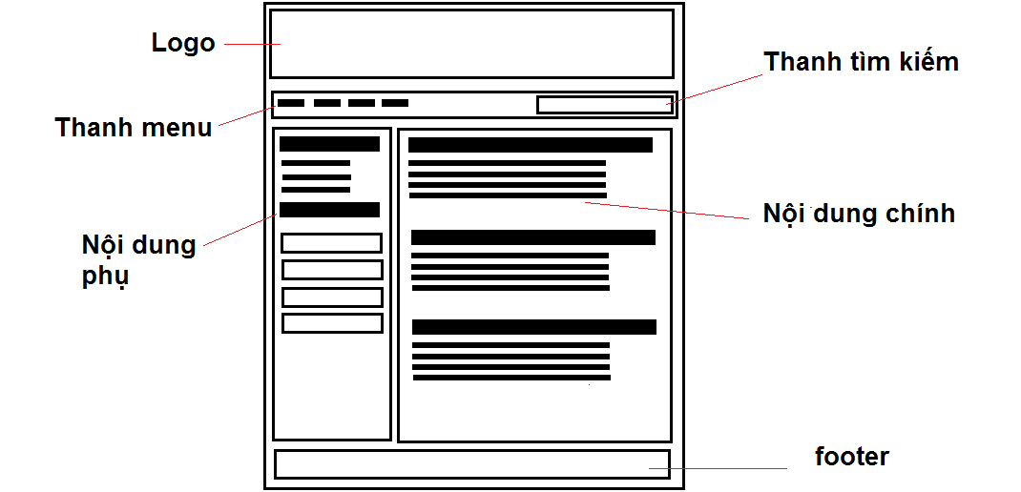

Kết quả cuối cùng ta hướng đến :

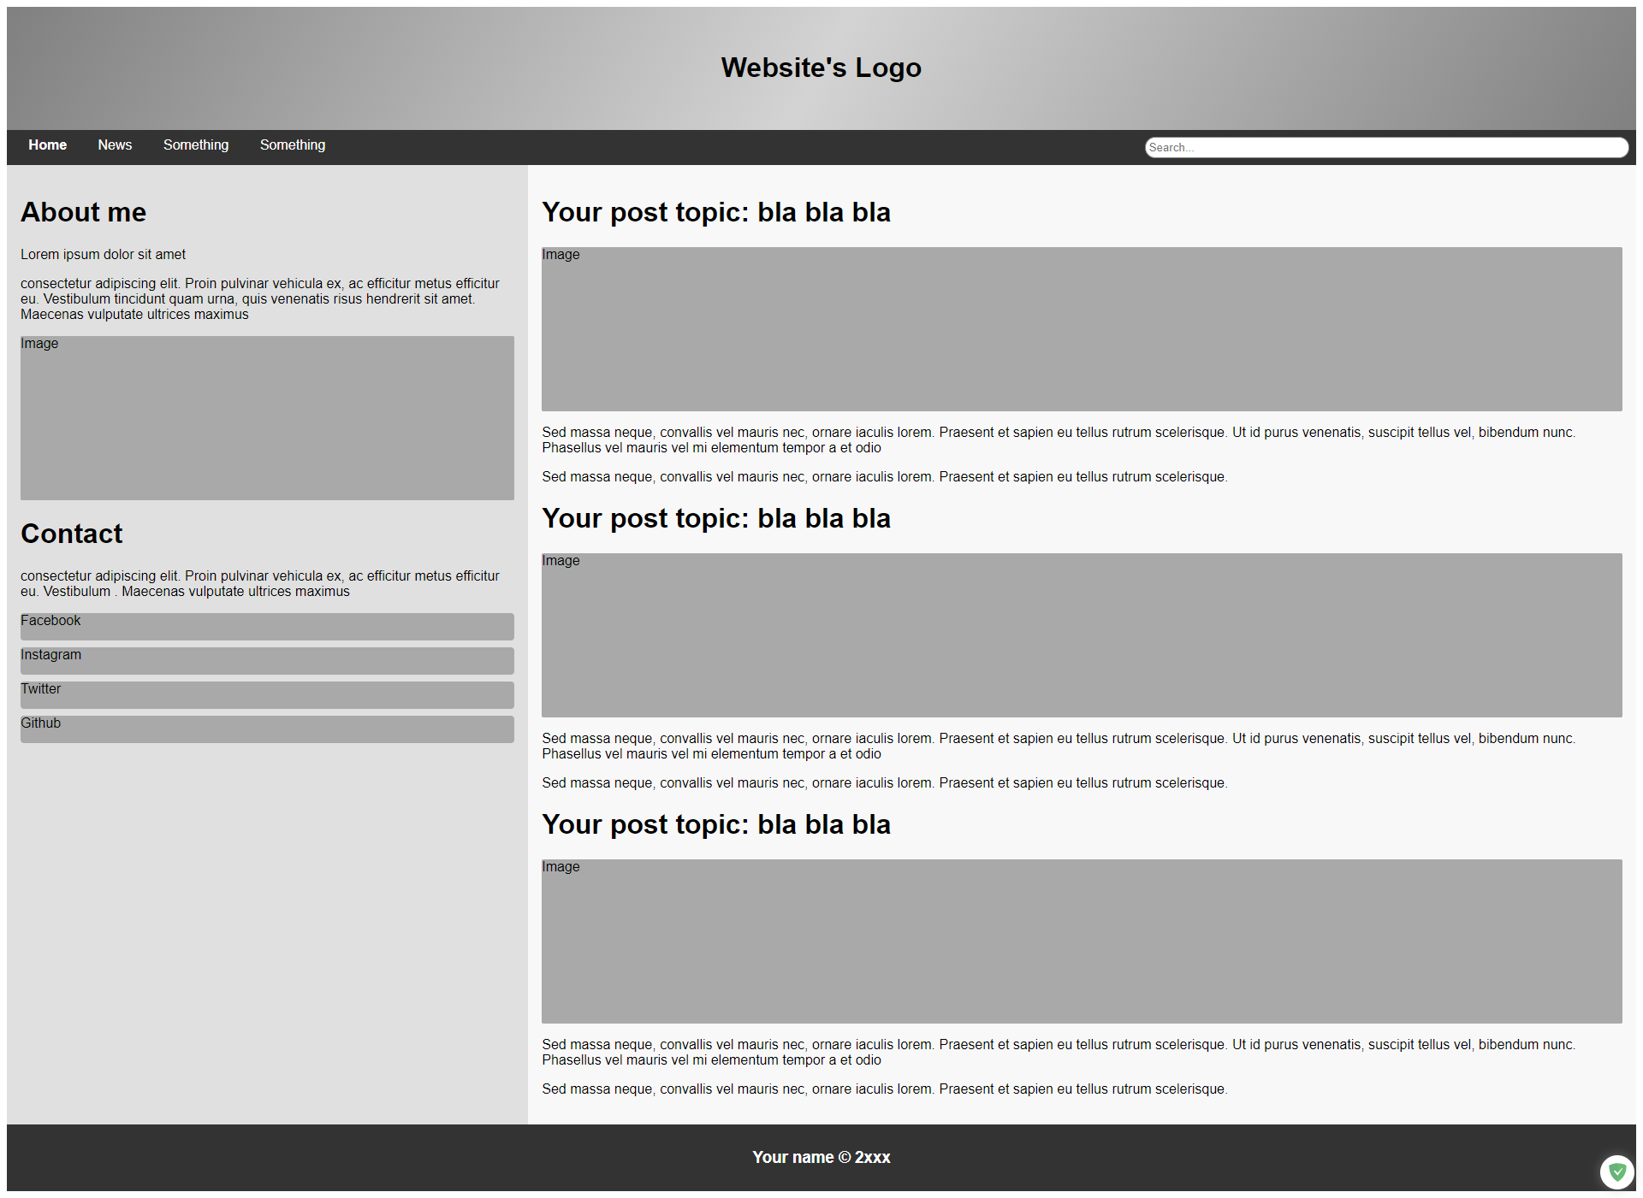

**Note: chú thêm phần “->** nội dung” để chú thích cho các phần css, bao giờ các cháu code thì bỏ nó đi, phần bôi đỏ là phần chú thêm mới sau mỗi bước.

Phần HTML nhớ bỏ trong phần thẻ body nhé.

# Bước 1 :

Chú sẽ tạo 1 cái khung html như thế này :

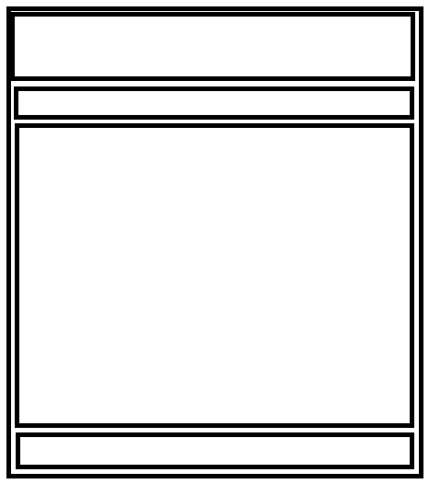

**HTML :**

<div class="container">

<div class="header"></div>

<div class="nav"></div>

<div class="section"></div>

<div class="footer"></div>

</div>

**CSS :**

<style type="text/css">  
 .container {  
 display: flex;  
 flex-direction: column;  
 }  
 .container > div {  
 border: 1px solid black;  
 }  
</style>

# Bước 2 :

Tiếp đến chú xây phần header.

HTML :

*<!--day la flex-->*<div class="container">  
*<!-- day la flex item-->* <div class="header">  
 <h1>Website's Logo</h1> -> đây là phần thêm này  
 </div>  
 <div class="nav"></div>  
 <div class="section"></div>  
 <div class="footer"></div>  
</div>

CSS :

<style type="text/css">  
 .container {  
 display: flex;  
 flex-direction: column;  
 }  
 .container > div {  
 border: 1px solid black; -> phần này chú thêm border vào để các cháu dễ quan sát sự thay đổi layout, bao giờ hoạn thiện mình bỏ đi  
 }  
  
 */*header*/* .header {  
 background: linear-gradient(120deg, gray, lightgray, gray); -> màu nền  
 text-align: center; -> căn giữa chữ  
 padding: 2em 1em; -> padding cho thằng h2 vào trung tâm  
 }  
</style>

Kết quả là :



# Bước 3:

Ta xây dựng tiếp đến phần này



Chia phần này ra làm đôi

HTML :

*<!--day la flex-->*<div class="container">  
*<!-- day la flex item-->* <div class="header">  
 <h1>Website's Logo</h1>  
 </div>  
 <div class="nav"> -> biến thằng này thành display:flex

*<!-- day la flex item-->*  
 <div class="menu">  
 </div>  
 <div class="search-zone">  
 </div>  
 </div>  
 <div class="section"></div>  
 <div class="footer"></div>  
</div>

CSS :

.container {  
 display: flex;  
 flex-direction: column;  
}  
.container > div {  
 border: 1px solid black;  
}  
  
*/*header*/*.header {  
 background: linear-gradient(120deg, gray, lightgray, gray);  
 text-align: center;  
 padding: 2em 1em;  
}  
  
.nav {  
 display: flex; */* lại để thằng div có class nav này thành 1 thằng flex với hướng trả flex item là row*/* flex-direction: row;  
 background-color: #333;  
}

Bước 3.1

HTML :

*<!--day la flex-->*<div class="container">  
*<!-- day la flex item-->* <div class="header">  
 <h1>Website's Logo</h1>  
 </div>  
 <div class="nav">  
 <div class="menu">  
*<!-- thêm phần điều hướng, các đường link ..-->* <a class="active" href="#link">Home</a>  
 <a href="#link">News</a>  
 <a href="#link">Something</a>  
 <a href="#link">Something</a>  
 </div>  
 <div class="search-zone">  
*<!-- thêm phần hiển thị tìm kiếm-->* <form>  
 <input placeholder="Search..." type="text">  
 </form>  
 </div>  
 </div>  
 <div class="section"></div>  
 <div class="footer"></div>  
</div>

CSS :

<style type="text/css">  
 .container {  
 display: flex;  
 flex-direction: column;  
 }  
 .container > div {  
 border: 1px solid black;  
 }  
  
 */*header*/* .header {  
 background: linear-gradient(120deg, gray, lightgray, gray);  
 text-align: center;  
 padding: 2em 1em;  
 }  
  
 .nav {  
 display: flex; */* lại để thằng div có class nav này thành 1 thằng flex với hướng trả flex item là row*/* flex-direction: row;  
 background-color: #333;  
 }  
  
 */*menu*/* .menu {  
 flex: 70%; -> item này sẽ chiếm 70% kích cỡ flex theo flex-direction (70% theo chiều ngang)  
 padding: 0.6em;  
 }  
  
 .nav a {  
 text-decoration: none; -> bỏ hết thuộc tính mặc định của thẻ a  
 color: white; -> màu chữ  
 margin: 1em;   
 }  
  
 .nav a:hover {  
 font-weight: bold; -> khi di chuột vào thẻ a thì sẽ bold đậm chữ  
 color: red; -> khi di chuột thẻ a sẽ hiển thị màu đỏ  
}

*/*search*/* .search-zone {  
 flex: 30%; -> vùng này sẽ chiếm 30% của flex theo chiều ngang  
 margin: 0.5em;  
 }  
  
  
 .search-zone input[type="text"] {  
 width: 100%;  
 padding: 0.3em;  
 border-radius: 1em; -> bo tròn thẻ input  
 border: 1px solid gray; -> thêm border cho thẻ input  
 outline: none;  
 }  
</style>

Kết quả:

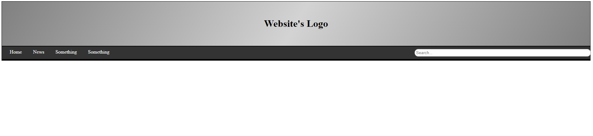

# Bước 4:

Ta làm tới phần này :

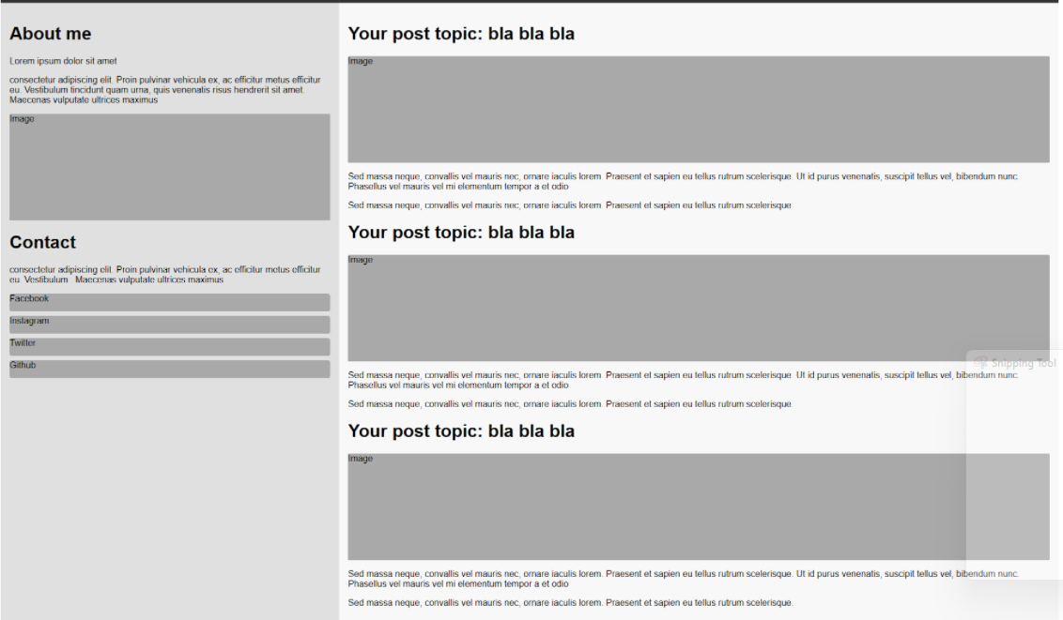

Tư duy ta lại tiếp tục break nhỏ nó ra :

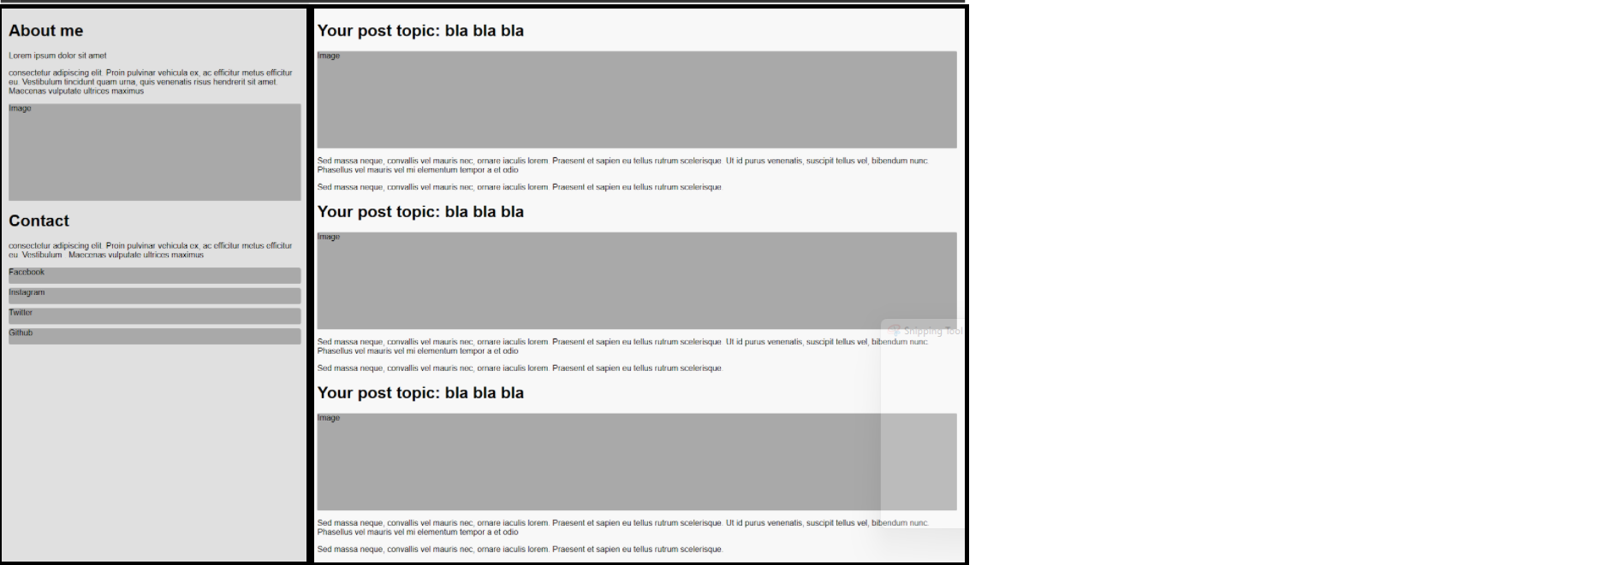

HTML:

*<!--day la flex-->*<div class="container">  
*<!-- day la flex item-->* <div class="header">  
 <h1>Website's Logo</h1>  
 </div>  
 <div class="nav">  
 <div class="menu">  
*<!-- thêm phần điều hướng, các đường link ..-->* <a class="active" href="#link">Home</a>  
 <a href="#link">News</a>  
 <a href="#link">Something</a>  
 <a href="#link">Something</a>  
 </div>  
 <div class="search-zone">  
*<!-- thêm phần hiển thị tìm kiếm-->* <form>  
 <input placeholder="Search..." type="text">  
 </form>  
 </div>  
 </div>  
 <div class="section"> *<!-- biến nó thành flex display:flex-->* <div class="aside">  
 </div>  
 <div class="article">  
 </div>  
 </div>  
 <div class="footer"></div>  
</div>

CSS :

<style type="text/css">  
 .container {  
 display: flex;  
 flex-direction: column;  
 }  
 .container > div {  
 border: 1px solid black;  
 }  
  
 */*header*/* .header {  
 background: linear-gradient(120deg, gray, lightgray, gray);  
 text-align: center;  
 padding: 2em 1em;  
 }  
  
 .nav {  
 display: flex; */* lại để thằng div có class nav này thành 1 thằng flex với hướng trả flex item là row*/* flex-direction: row;  
 background-color: #333;  
 }  
  
 */*menu*/* .menu {  
 flex: 70%;  
 padding: 0.6em;  
 }  
  
 .nav a {  
 text-decoration: none;  
 color: white;  
 margin: 1em;  
 }  
  
 .nav a:hover {  
 font-weight: bold;  
 color: red;  
 }  
  
 */*search*/* .search-zone {  
 flex: 30%;  
 margin: 0.5em;  
 }  
  
  
 .search-zone input[type="text"] {  
 width: 100%;  
 padding: 0.3em;  
 border-radius: 1em;  
 border: 1px solid gray;  
 }  
  
  
 */**content**/* .section {  
 display: flex;  
 }  
*/*left side*/*.aside {  
 flex: 32%; -> độ rộng 32 % của flex  
 background-color: #e0e0e0;  
 padding: 1em;  
}

*/*main side*/*.article {  
 flex: 68%; -> độ rộng 68 % của flex  
 background-color: #f8f8f8;  
 padding: 1em;  
}

</style>

Bước 4.1

Thêm nội dung vào div có class .aside

HTML : ở phần này chú cũng có thể biến nó thành display:flex và lại trải theo chiều dọc.

<div class="aside">  
 <h1>About me</h1>  
 <p>Lorem ipsum dolor sit amet</p>  
 <p>consectetur adipiscing elit. Proin pulvinar vehicula ex, ac efficitur metus efficitur eu. Vestibulum  
 tincidunt quam urna, quis venenatis risus hendrerit sit amet. Maecenas vulputate ultrices maximus</p>  
 <div id="fakeimg4">  
 Image  
 </div>  
 <h1>Contact</h1>  
 <p>consectetur adipiscing elit. Proin pulvinar vehicula ex, ac efficitur metus efficitur eu. Vestibulum .  
 Maecenas vulputate ultrices maximus</p>  
 <div class="contact-box">  
 <div class="box">Facebook</div>  
 <div class="box">Instagram</div>  
 <div class="box">Twitter</div>  
 <div class="box">Github</div>  
 </div>  
</div>

CSS :

Bước 4.2 :

Tiếp tục xử lý đến phần bên phải :

HTML :

Thêm vào trong div có class là article :

HTML:

<div class="article">  
 <div class="post">  
 </div>  
 <div class="post">  
 </div>  
 <div class="post">  
 </div>  
</div>

CSS :

*/*main side*/*.article {  
 flex: 68%;  
 background-color: #f8f8f8;  
 padding: 1em;

display: flex;  
flex-direction: column;

}

Bước 4.2:

HTML

Thêm vào đúng chỗ :

<div class="article">  
 <div class="post">  
 <h1>Your post topic: bla bla bla</h1>  
 <div id="fakeimg1">Image</div>  
 <p>Sed massa neque, convallis vel mauris nec, ornare iaculis lorem. Praesent et sapien eu tellus rutrum  
 scelerisque. Ut id purus venenatis, suscipit tellus vel, bibendum nunc. Phasellus vel mauris vel mi  
 elementum tempor a et odio</p>  
 <p>Sed massa neque, convallis vel mauris nec, ornare iaculis lorem. Praesent et sapien eu tellus rutrum  
 scelerisque.</p>  
 </div>  
 <div class="post">  
 <h1>Your post topic: bla bla bla</h1>  
 <div id="fakeimg2">Image</div>  
 <p>Sed massa neque, convallis vel mauris nec, ornare iaculis lorem. Praesent et sapien eu tellus rutrum  
 scelerisque. Ut id purus venenatis, suscipit tellus vel, bibendum nunc. Phasellus vel mauris vel mi  
 elementum tempor a et odio</p>  
 <p>Sed massa neque, convallis vel mauris nec, ornare iaculis lorem. Praesent et sapien eu tellus rutrum  
 scelerisque.</p>  
 </div>  
 <div class="post">  
 <h1>Your post topic: bla bla bla</h1>  
 <div id="fakeimg3">Image</div>  
 <p>Sed massa neque, convallis vel mauris nec, ornare iaculis lorem. Praesent et sapien eu tellus rutrum  
 scelerisque. Ut id purus venenatis, suscipit tellus vel, bibendum nunc. Phasellus vel mauris vel mi  
 elementum tempor a et odio</p>  
 <p>Sed massa neque, convallis vel mauris nec, ornare iaculis lorem. Praesent et sapien eu tellus rutrum  
 scelerisque.</p>  
 </div>  
  
</div>

CSS :

#fakeimg1 {  
 height: 12em;  
 background-color: darkgray;  
 border-radius: 2px;  
 width: 100%;  
}  
  
#fakeimg2 {  
 height: 12em;  
 background-color: darkgray;  
 border-radius: 2px;  
 width: 100%;  
}  
  
#fakeimg3 {  
 height: 12em;  
 background-color: darkgray;  
 border-radius: 2px;  
 width: 100%;  
}  
  
#fakeimg4 {  
 height: 12em;  
 background-color: darkgray;  
 border-radius: 2px;  
 width: 100%;  
}

*/*main side*/*.article {  
 flex: 68%;  
 background-color: #f8f8f8;  
 padding: 1em;  
 display: flex;  
 flex-direction: column;  
}  
  
.post h1 {  
 font-size: 32px;  
}

Kết quả : 

Bước 5: Tương tự làm nốt với các phần còn lại

=> tư duy chia flex như chia table thôi.

# Final code hoàn chỉnh :

HTML:

<!DOCTYPE html>  
<html lang="en">  
<head>  
 <meta charset="UTF-8">  
 <title>Title</title>  
 <style>  
 * {  
 box-sizing: border-box;  
 }  
 .container {  
 display: flex;  
 flex-direction: column;  
 }  
 body {  
 font-family: sans-serif;  
 }  
  
 */*header*/* .header {  
 background: linear-gradient(120deg, gray, lightgray, gray);  
 text-align: center;  
 padding: 2em 1em;  
 }  
  
 */**navigation bar**/* .nav {  
 display: flex;  
 background-color: #333;  
 }  
  
 */*menu*/* .menu {  
 flex: 70%;  
 padding: 0.6em;  
 }  
  
 .nav a {  
 text-decoration: none;  
 color: white;  
 margin: 1em;  
 }  
  
 .nav a:hover {  
 color: red;  
 font-weight: bold;  
 }  
  
 */*search*/* .search-zone {  
 flex: 30%;  
 margin: 0.5em;  
 }  
  
 .search-zone input[type="text"] {  
 width: 100%;  
 padding: 0.3em;  
 border-radius: 1em;  
 border: 1px solid gray;  
 outline: none;  
 }  
  
 .search-zone input[type="text"]:focus {  
 background-color: lightgray;  
 }  
  
 */**content**/* .section {  
 display: flex;  
 }  
  
 */*left side*/* .aside {  
 flex: 32%;  
 background-color: #e0e0e0;  
 padding: 1em;  
 }  
  
 #fakeimg1 {  
 height: 12em;  
 background-color: darkgray;  
 border-radius: 2px;  
 width: 100%;  
 }  
  
 #fakeimg2 {  
 height: 12em;  
 background-color: darkgray;  
 border-radius: 2px;  
 width: 100%;  
 }  
  
 #fakeimg3 {  
 height: 12em;  
 background-color: darkgray;  
 border-radius: 2px;  
 width: 100%;  
 }  
  
 #fakeimg4 {  
 height: 12em;  
 background-color: darkgray;  
 border-radius: 2px;  
 width: 100%;  
 }  
  
 .contact-box .box {  
 width: 100%;  
 height: 2em;  
 margin-top: 0.5em;  
 border-radius: 4px;  
 background-color: darkgray;  
 }  
  
 */*main side*/* .article {  
 flex: 68%;  
 background-color: #f8f8f8;  
 padding: 1em;  
 display: flex;  
 flex-direction: column;  
 }  
  
 .post h1 {  
 font-size: 32px;  
 }  
  
 */*footer*/* .footer {  
 background-color: #333;  
 text-align: center;  
 color: white;  
 padding: 0.6em;  
 }  
  
 </style>  
</head>  
<body>  
<div class="container">  
 <div class="header">  
 <h1>Website's Logo</h1>  
 </div>  
 <div class="nav">  
 <div class="menu">  
 <a class="active" href="#link">Home</a>  
 <a href="#link">News</a>  
 <a href="#link">Something</a>  
 <a href="#link">Something</a>  
 </div>  
 <div class="search-zone">  
 <form>  
 <input placeholder="Search..." type="text">  
 </form>  
 </div>  
 </div>  
 <div class="section">  
 <div class="aside">  
 <h1>About me</h1>  
 <p>Lorem ipsum dolor sit amet</p>  
 <p>consectetur adipiscing elit. Proin pulvinar vehicula ex, ac efficitur metus efficitur eu. Vestibulum  
 tincidunt quam urna, quis venenatis risus hendrerit sit amet. Maecenas vulputate ultrices maximus</p>  
 <div id="fakeimg4">  
 Image  
 </div>  
 <h1>Contact</h1>  
 <p>consectetur adipiscing elit. Proin pulvinar vehicula ex, ac efficitur metus efficitur eu. Vestibulum .  
 Maecenas vulputate ultrices maximus</p>  
 <div class="contact-box">  
 <div class="box">Facebook</div>  
 <div class="box">Instagram</div>  
 <div class="box">Twitter</div>  
 <div class="box">Github</div>  
 </div>  
 </div>  
 <div class="article">  
 <div class="post">  
 <h1>Your post topic: bla bla bla</h1>  
 <div id="fakeimg1">Image</div>  
 <p>Sed massa neque, convallis vel mauris nec, ornare iaculis lorem. Praesent et sapien eu tellus rutrum  
 scelerisque. Ut id purus venenatis, suscipit tellus vel, bibendum nunc. Phasellus vel mauris vel mi  
 elementum tempor a et odio</p>  
 <p>Sed massa neque, convallis vel mauris nec, ornare iaculis lorem. Praesent et sapien eu tellus rutrum  
 scelerisque.</p>  
 </div>  
 <div class="post">  
 <h1>Your post topic: bla bla bla</h1>  
 <div id="fakeimg2">Image</div>  
 <p>Sed massa neque, convallis vel mauris nec, ornare iaculis lorem. Praesent et sapien eu tellus rutrum  
 scelerisque. Ut id purus venenatis, suscipit tellus vel, bibendum nunc. Phasellus vel mauris vel mi  
 elementum tempor a et odio</p>  
 <p>Sed massa neque, convallis vel mauris nec, ornare iaculis lorem. Praesent et sapien eu tellus rutrum  
 scelerisque.</p>  
 </div>  
 <div class="post">  
 <h1>Your post topic: bla bla bla</h1>  
 <div id="fakeimg3">Image</div>  
 <p>Sed massa neque, convallis vel mauris nec, ornare iaculis lorem. Praesent et sapien eu tellus rutrum  
 scelerisque. Ut id purus venenatis, suscipit tellus vel, bibendum nunc. Phasellus vel mauris vel mi  
 elementum tempor a et odio</p>  
 <p>Sed massa neque, convallis vel mauris nec, ornare iaculis lorem. Praesent et sapien eu tellus rutrum  
 scelerisque.</p>  
 </div>  
  
 </div>  
 </div>  
 <div class="footer">  
 <h3>Your name &copy; 2xxx</h3>  
 </div>  
</div>  
</body>  
</html>